#define LED1 10

#define LED2 11

#define LED3 12

#define LED4 13

void setup() {

  // put your setup code here, to run once:

  pinMode(LED1, OUTPUT);

  pinMode(LED2, OUTPUT);

  pinMode(LED3, OUTPUT);

  pinMode(LED4, OUTPUT);

 }

void loop() {

  // put your main code here, to run repeatedly:

  digitalWrite(LED1, HIGH);

  delay(200);

  digitalWrite(LED1, LOW);

  delay(200);

  digitalWrite(LED2, HIGH);

  delay(200);

  digitalWrite(LED2, LOW);

  delay(200);

   digitalWrite(LED3, HIGH);

  delay(200);

  digitalWrite(LED3, LOW);

  delay(200);

   digitalWrite(LED4, HIGH);

  delay(200);

  digitalWrite(LED4, LOW);

  delay(200);

 }

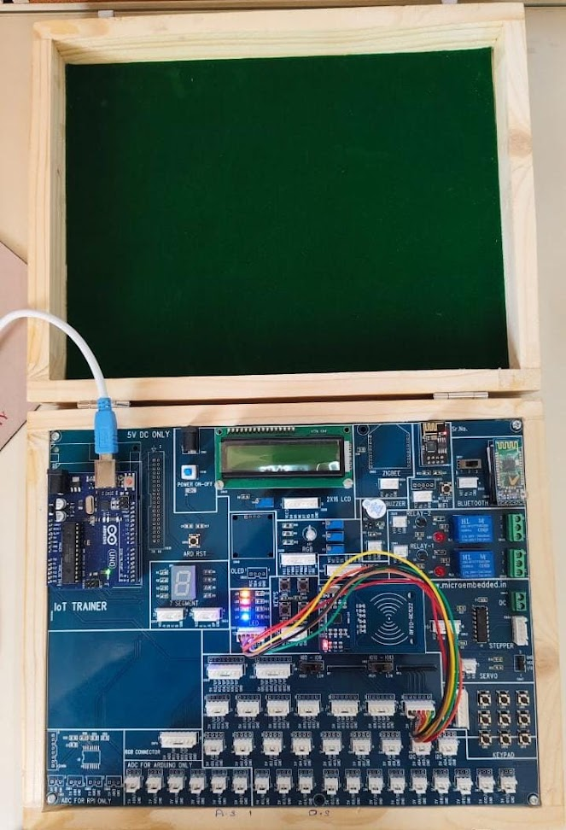

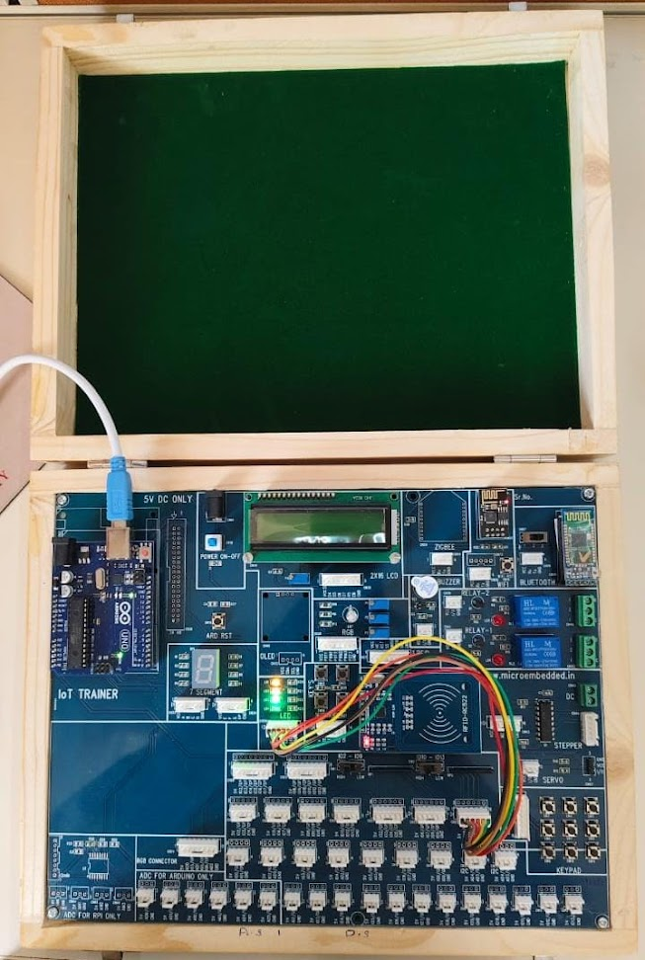

// Define pin numbers for LEDs

#define GREEN_LED 4

#define YELLOW_LED 2

#define RED_LED 3

// Initialize counter

int counter = 0;

void setup() {

  // Set LED pins as outputs

  pinMode(GREEN_LED, OUTPUT);

  pinMode(YELLOW_LED, OUTPUT);

  pinMode(RED_LED, OUTPUT);

}

void loop() {

  // Reset all LEDs

  digitalWrite(GREEN_LED, LOW);

  digitalWrite(YELLOW_LED, LOW);

  digitalWrite(RED_LED, LOW);

  // Illuminate the appropriate LED based on the counter value

  if (counter <= 100)

   {

    digitalWrite(GREEN_LED, LOW);

    digitalWrite(YELLOW_LED, HIGH);

    digitalWrite(RED_LED, HIGH);

    delay(20);

  }

  else if (counter > 100 && counter <= 200)

  {

    digitalWrite(YELLOW_LED, LOW);

    digitalWrite(GREEN_LED, HIGH);

    digitalWrite(RED_LED, HIGH);

     delay(20);

  } else if (counter > 200)

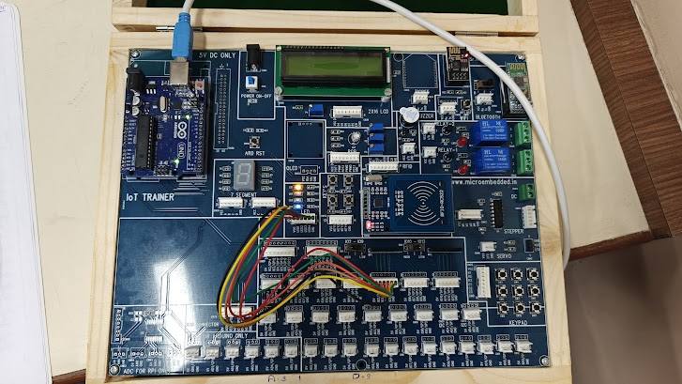

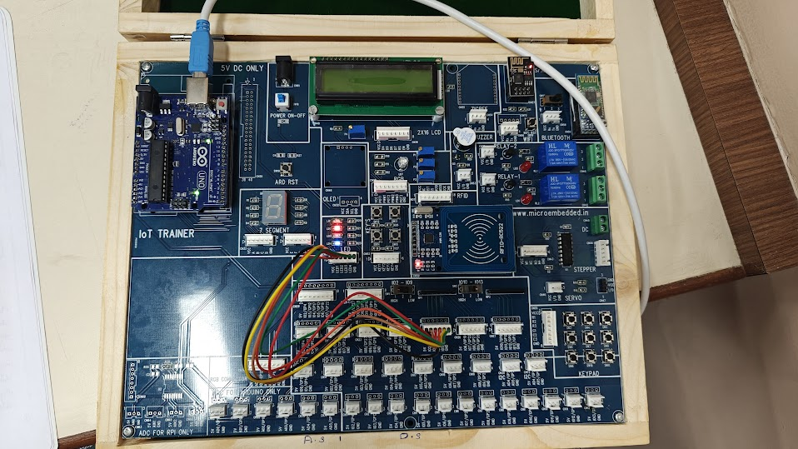

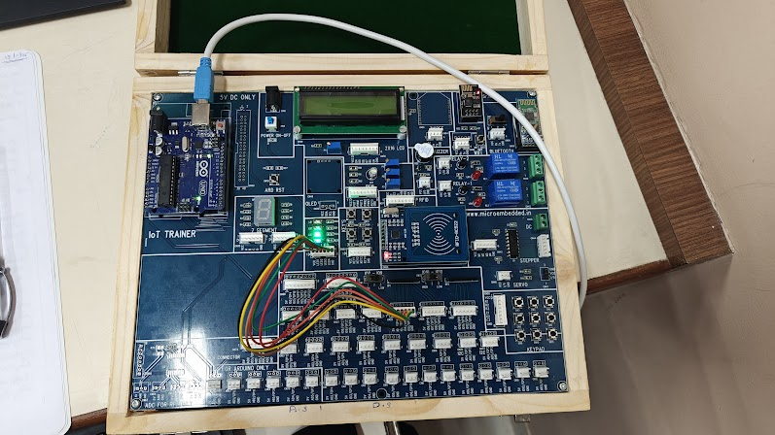

char ch;

void setup()

{

pinMode(3, OUTPUT);

pinMode(5, OUTPUT);

pinMode(6, OUTPUT);//Configures pins 3, 5, and 6 as output pins to

control the LEDs.

Serial.begin(9600);//Initializes serial communication with a baud rate of

9600.

}

void loop()

{

if(Serial.available()){

ch=Serial.read();

}

if(ch=='R'|| ch=='r'){

digitalWrite(3, LOW);

digitalWrite(5, HIGH);

digitalWrite(6, HIGH);

}

if(ch=='G'||ch=='g'){

digitalWrite(5, LOW);

digitalWrite(6, HIGH);

digitalWrite(3, HIGH);

}

if(ch=='B'||ch=='b'){

digitalWrite(6, LOW);

digitalWrite(5, HIGH);

digitalWrite(3, HIGH);

}

}

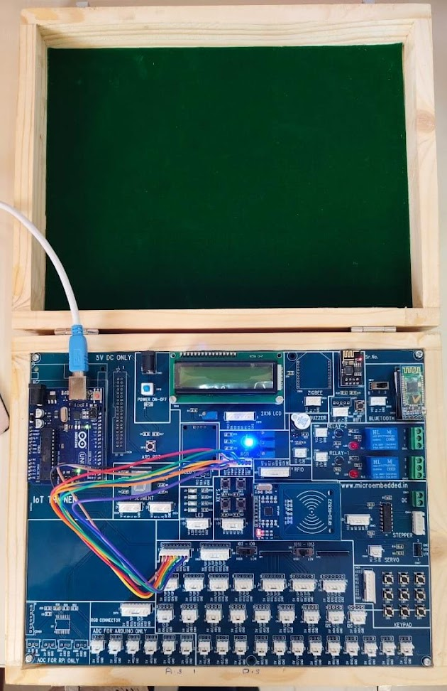

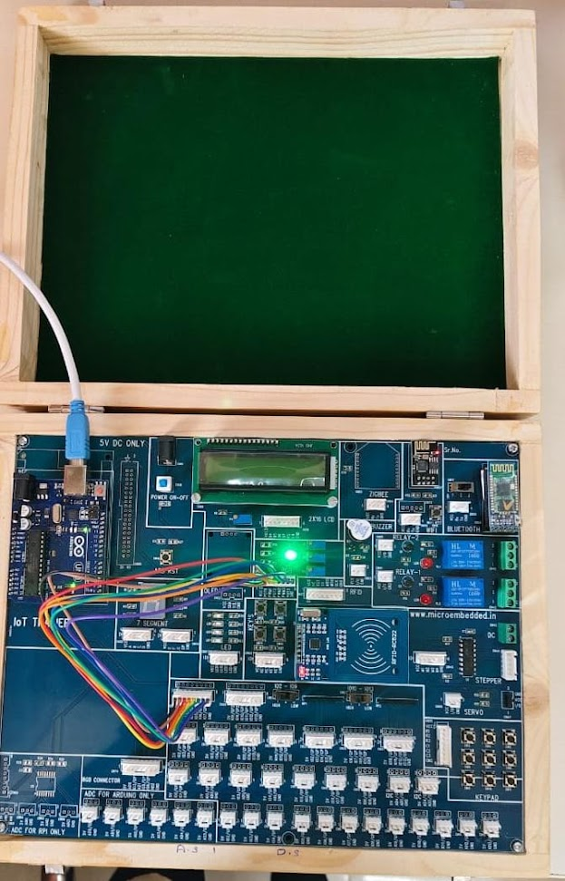

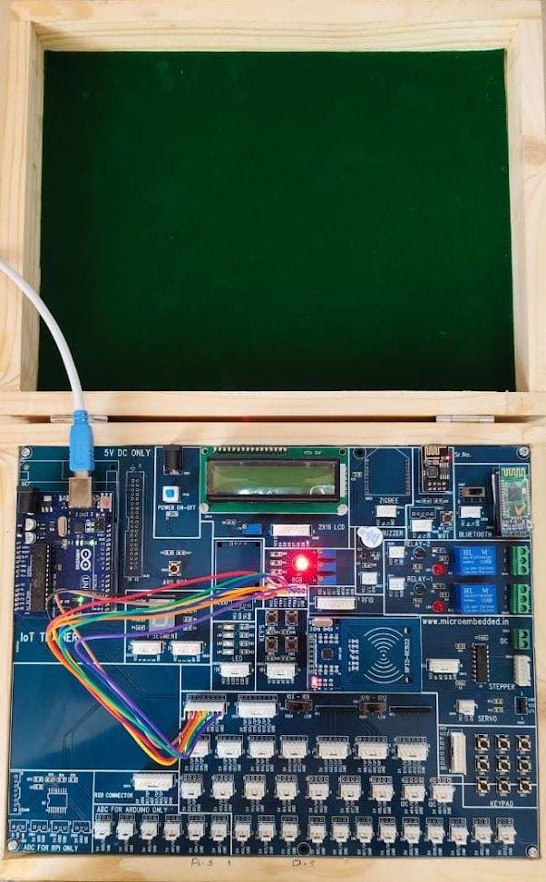

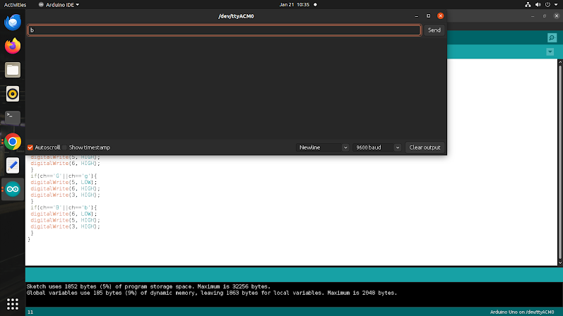

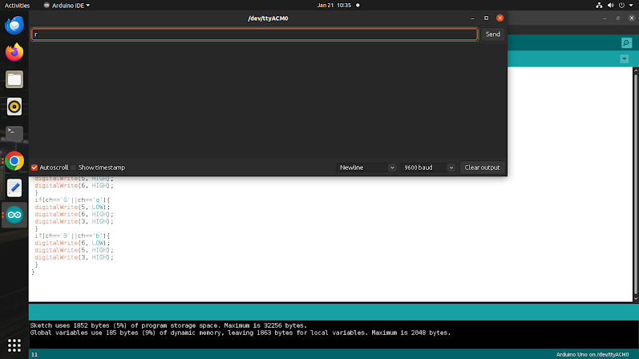

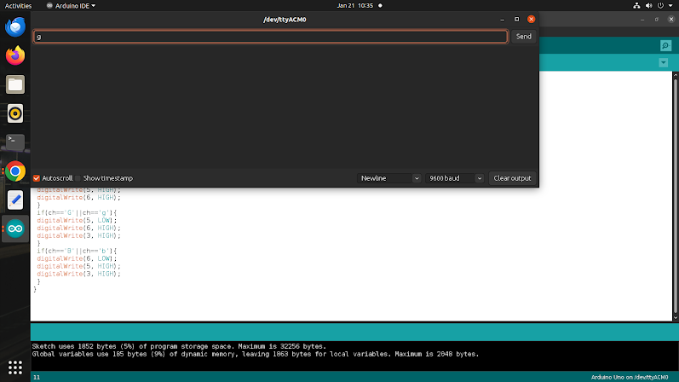

#include <DHT.h>

#define DHTPIN 2     // Pin where the DHT11 sensor is connected

#define DHTTYPE DHT11   // Type of sensor (DHT11 or DHT22)

DHT dht(DHTPIN, DHTTYPE);

void setup() {

  Serial.begin(9600);

  dht.begin();

}

void loop() {

  delay(2000);

  float temperature = dht.readTemperature(); // Read temperature in Celsius

  float humidity = dht.readHumidity();       // Read humidity

  if (isnan(temperature) || isnan(humidity)) {

    Serial.println("Failed to read from DHT sensor!");

    return;

  }

  Serial.print("Temperature: ");

  Serial.print(temperature);

  Serial.print(" °C, Humidity: ");

  Serial.print(humidity);

  Serial.println(" %");

}

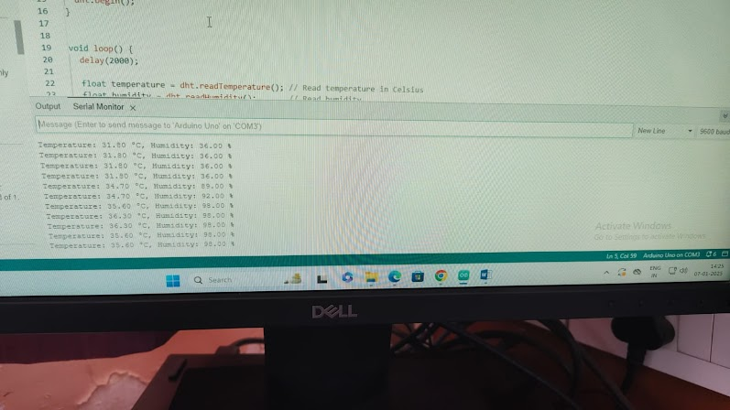

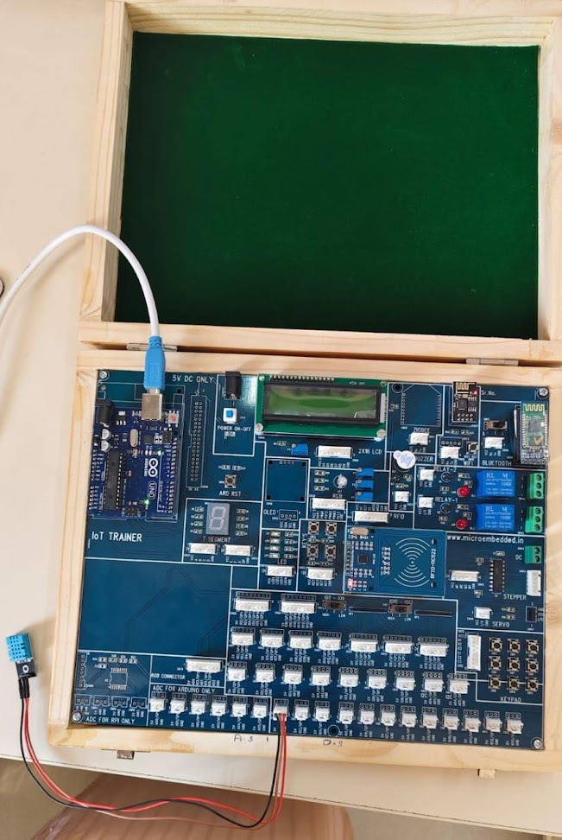

#include <DHT.h>

#define DHTPIN 2 // Pin where the DHT11 sensor is connected

#define DHTTYPE DHT11 // Type of sensor (DHT11 or DHT22)

DHT dht(DHTPIN, DHTTYPE);

float maxTemp = -1000; // Initialize max temperature to a very low value

float minTemp = 1000; // Initialize min temperature to a very high value

void setup() {

Serial.begin(9600);

dht.begin();

}

void loop() {

delay(2000);

// Read temperature in Celsius

float temperatureC = dht.readTemperature();

// Read temperature in Fahrenheit

float temperatureF = temperatureC * 9.0 / 5.0 + 32.0;

// Update max and min temperatures

if (temperatureC > maxTemp) {

maxTemp = temperatureC;

}

if (temperatureC < minTemp) {

minTemp = temperatureC;

}

// Display temperature in Celsius and Fahrenheit

Serial.print("Temperature: ");

Serial.print(temperatureC);

Serial.print(" °C, ");

Serial.print(temperatureF);

Serial.println(" °F");

// Display maximum and minimum temperatures seen

Serial.print("Max Temperature: ");

Serial.print(maxTemp);

Serial.print(" °C, Min Temperature: ");

Serial.print(minTemp);

Serial.println(" °C");

}

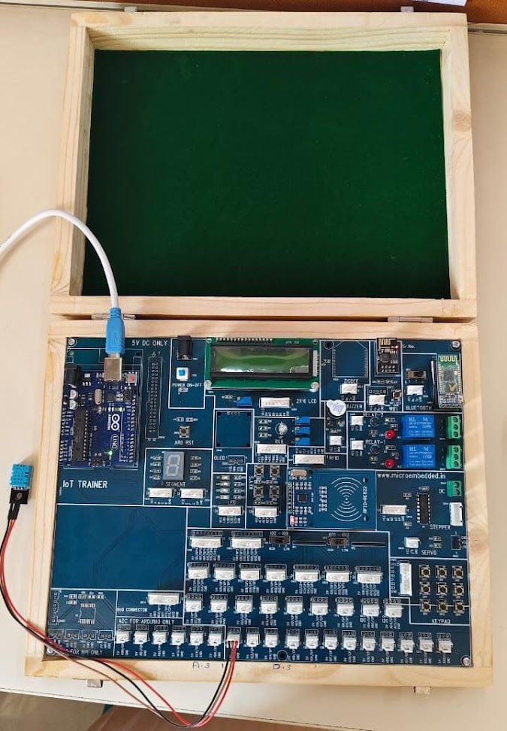

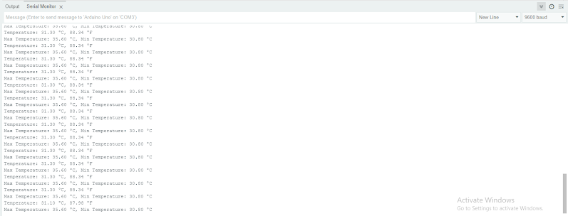

#include "dht.h"

#define dataPin 2

dht DHT;

int temp;

int hum;

void setup() {

Serial.begin(9600);

delay(2000); // Wait for the DHT sensor to stabilize

}

void loop() {

int readData = DHT.read11(dataPin);

hum = DHT.humidity;

temp = DHT.temperature;

// Output data formatted for Serial Plotter

Serial.print(hum); // Humidity

Serial.print(","); // Separator

Serial.println(temp); // Temperature

delay(1000); // Wait 1 second before next reading

}

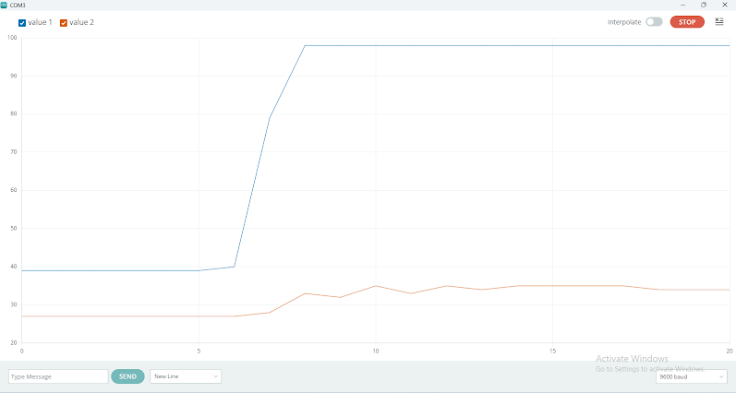

// Define the pin for the piezo buzzer

#define BUZZER_PIN 8

void setup() {

tone(BUZZER_PIN, 440, 500); // Play A4 (440 Hz) for 500 ms

delay(1000); // Wait for 1 second

tone(BUZZER_PIN, 523, 500); // Play C5 (523 Hz) for 500 ms

delay(1000); // Wait for 1 second

}

void loop() {

// No code needed in loop

}

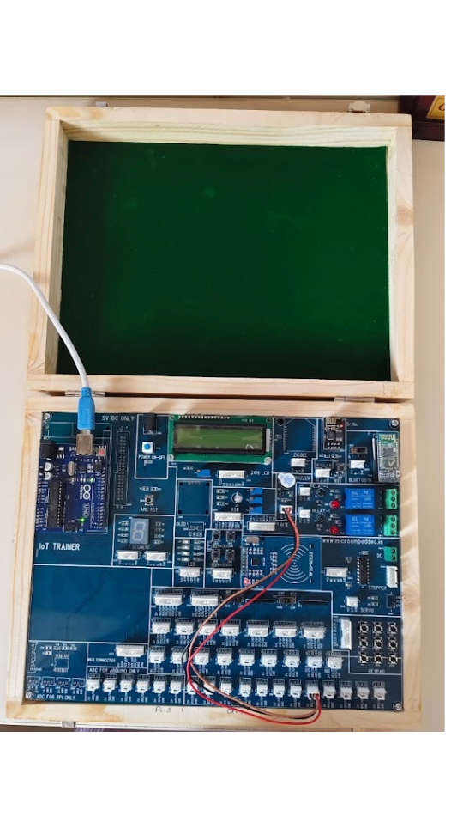

void setup()

{

pinMode(3, OUTPUT);

pinMode(10, INPUT);

}

void loop() {

int hasObstacle = digitalRead(10);

if (hasObstacle == 1) {

digitalWrite(3, HIGH);

}

else {

digitalWrite(3, LOW);

}

delay(200);

}

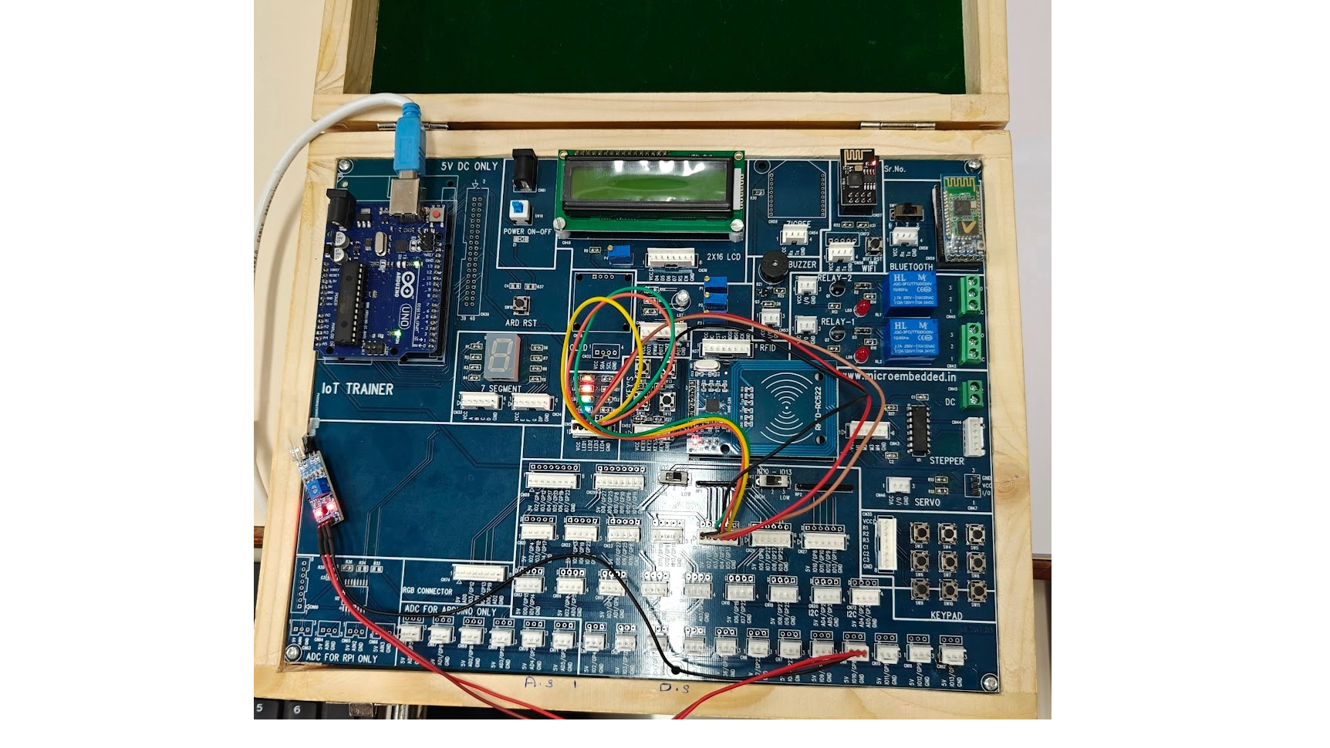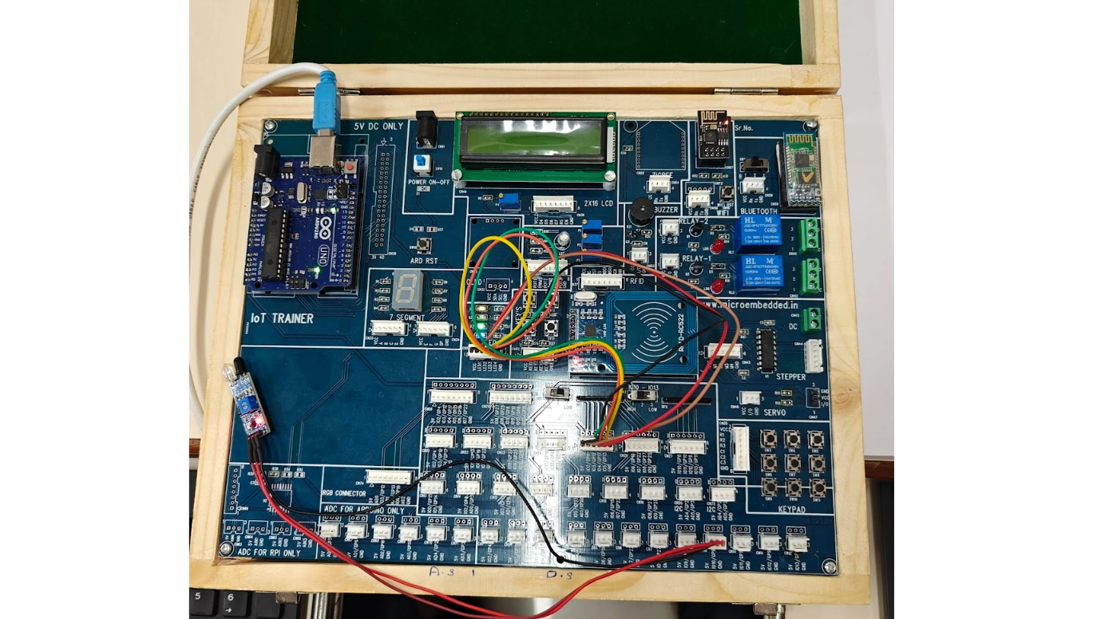

int pirPin = 7;      // Pin connected to PIR sensor OUT

int ledPin = 13;     // Pin connected to LED (optional)

void setup() {

  pinMode(pirPin, INPUT);  // Set PIR sensor pin as input

  pinMode(ledPin, OUTPUT); // Set LED pin as output (optional)

  Serial.begin(9600);      // Start serial communication

}

void loop() {

  int motion = digitalRead(pirPin);  // Read the state of the PIR sensor

  if (motion == HIGH) {

    // Motion detected

    digitalWrite(ledPin, HIGH);  // Turn ON LED (optional)

    Serial.println("PIR Motion Detected !");

  } else {

    // No motion

    digitalWrite(ledPin, LOW);   // Turn OFF LED (optional)

    Serial.println("PIR not detected any motion");

  }

  delay(1000);  // Small delay to prevent excessive serial printing

}

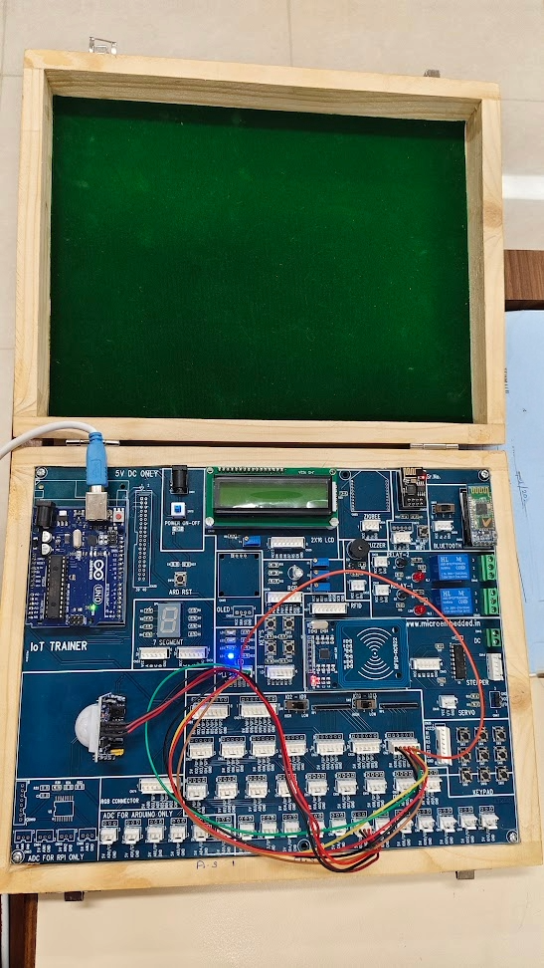

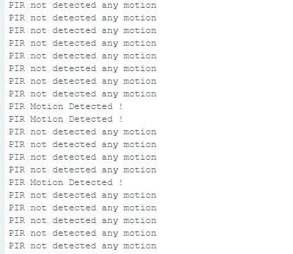

void setup() {

pinMode(2,OUTPUT);

pinMode(3,OUTPUT);

pinMode(4,OUTPUT);

pinMode(5,OUTPUT);

}

void loop() {

  digitalWrite(2,HIGH);

  digitalWrite(3,LOW);

  digitalWrite(4,LOW);

  digitalWrite(5,LOW);

  delay(10);

   digitalWrite(2,LOW);

  digitalWrite(3,HIGH);

  digitalWrite(4,LOW);

  digitalWrite(5,LOW);

  delay(10);

   digitalWrite(2,LOW);

  digitalWrite(3,LOW);

  digitalWrite(4,HIGH);

  digitalWrite(5,LOW);

  delay(10);

  digitalWrite(2,LOW);

  digitalWrite(3,LOW);

  digitalWrite(4,LOW);

  digitalWrite(5,HIGH);

  delay(10);

}

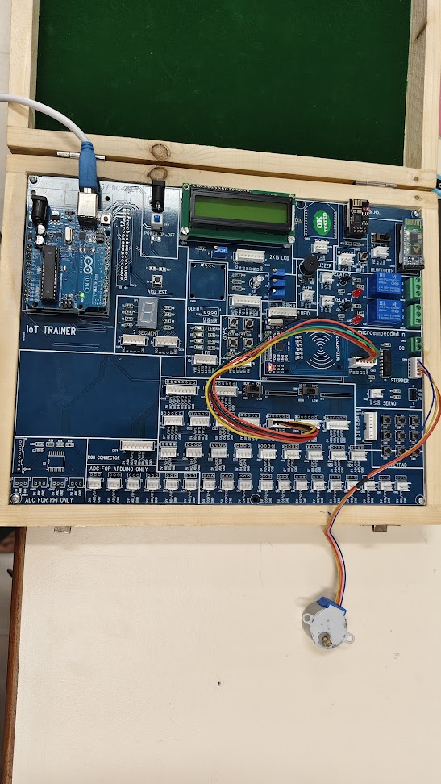

#define TRIG_PIN 8  // Define the Trigger pin

#define ECHO_PIN 9 // Define the Echo pin

void setup() {

  Serial.begin(9600);       // Initialize serial communication at 9600 baud rate

  pinMode(TRIG_PIN, OUTPUT); // Set Trigger pin as output

  pinMode(ECHO_PIN, INPUT);  // Set Echo pin as input

}

void loop() {

  long duration;

  float distance;

  // Send a 10-microsecond pulse to trigger pin

  digitalWrite(TRIG_PIN, LOW);

  delayMicroseconds(2);

  digitalWrite(TRIG_PIN, HIGH);

  delayMicroseconds(10);

  digitalWrite(TRIG_PIN, LOW);

  // Measure the echo pulse duration

  duration = pulseIn(ECHO_PIN, HIGH);

  // Convert time into distance (in cm)

  distance = duration * 0.034 / 2;

  // Print the distance value on Serial Monitor

  Serial.print("Distance: ");

  Serial.print(distance);

  Serial.println(" cm");

  delay(500); // Wait 500ms before next reading

}

